📝 Readme
Daily Concept Learning
"ஒரு பெரிய வெற்றி என்பது தினசரி செய்யும் சிறு முயற்சிகளின் விளைவுதான்!"

Communication
DSA |  | Java |  |  | React JS
Spring Boot Microservices | DB (Mysql, Postgres, NoSQL) | Queue (Kafka, Rabbit MQ) |  | Security
System Design | Design Pattern | Scalability and Performance |  | Monitoring and Observability
Dev Ops (Docker → CI / CD → Kubernetes → Terraform)
AWS

🗣️ Communication
- எந்த ஒரு concepts ஐயும், எளிதாக புரியும்படி சொல்லவேண்டும்
- சரளமாக பேசுவதற்கு , எழுதுவதற்கு கண்டிப்பாக தினசரி பயற்சி எடுக்க வேண்டும் `

📚 Java
- JVM Internals (Memory model, GC basic, class loading)
- OOP concepts
- SOLID principles
- Java 8 features
- Concurrency, threads, executors, futures, Compatible future, Locks vs atomics.
- exceptions , Immutability, records, lombok
- Streams, optionals

🪜 Stream API
Java 8 Streams, lambdas, intermediate vs terminal ops, and lazy loading with simple examples
A stream is an infinite sequence of consumable elements (i.e a data structure) for the consumption of an operation or iteration. Any Collection<T> can be exposed as a stream. It looks complex, but once you get it, it is very simple. The operations you perform on a stream can either be

1. Intermediate operations like map, filter, sorted, limit, skip, concat, substream, distinct, peek, etc producing another java.util.stream.Stream<T> or a

2. Terminal operations like forEach, reduce, collect, sum, max, count, matchAny, findFirst, findAny, etc produce an object that is not a stream.

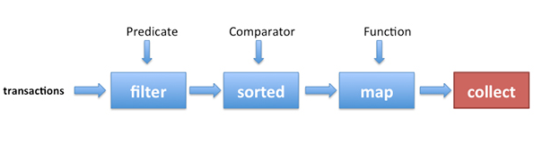
Streams: intermediate(blue) & terminal (red)
Basically, you are building a pipeline as in Unix. In Unix we “pipe” operations, and in Java 8, we stream them.
ls -l | grep “Dec” | Sort +4n | more
ls -l | grep “Dec” | Sort +4n | more

The stream( ) is a default method added to the Collection<T>interface in Java 8. The stream( ) returns a java.util.starem.Stream<T> interface with multiple abstract methods like filter, map, sorted, collect, etc.

The DelegatingStream<T> is the implementing class.
Intermediate operations are lazy operations, which will be executed only after a terminal operation was executed. So when you call filter(i -> i % 3 == 0) the lambda body isn’t being executed at the moment. It will only be executed after a terminal operation is called (collect, in the example shown below). This is essential to understand from the viewpoint of adding breakpoints in your IDE for debugging purposes.

Go through these examples to get a good handle on the stream concepts.
11 numbers 1 to 10 and an extra 6 are
a) filtered first for multiples of 3
b) filtered for values less than 7
c) remove duplicates by adding to a Set<T>
d) print the result.
i -> i % 3 == 0 is a lambda expression used as a predicate to filter only multiples of 3. So,
Q. What is this “lambda expression”?
A. In OOP or imperative programming, x = x+ 5 makes sense, but in mathematics or functional programming, you can’t say x = x + 5 because if x were to be 2, you can’t say that 2 = 2 + 5. In functional programming you need to say f(x) -> x + 5.
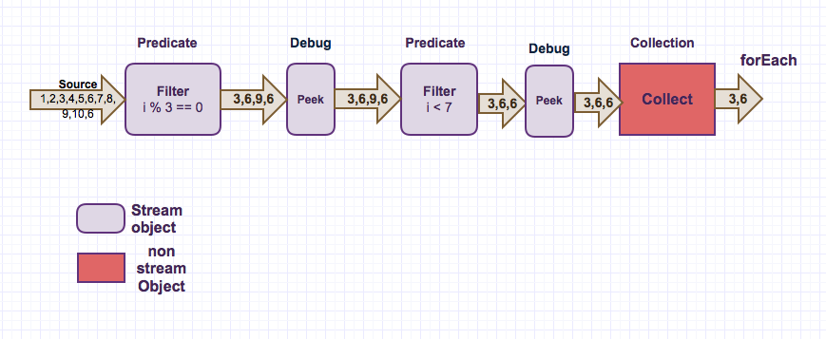
Java 8 Stream
Example 1:
import java.util.Arrays; import java.util.List; import java.util.stream.Collectors; public class Java8LambdaDebug { public static void main(String[] args) { List<Integer> list = Arrays.asList(1,2,3,4,5,6,7,8,9,10, 6);// 6 is repeated list.stream() .filter(i -> i % 3 == 0) //multiples of 3 .peek(i -> System.out.println("Debug pt1: " + i)) .filter(i -> i < 7) .peek(i -> System.out.println("Debug pt2: " + i)) .collect(Collectors.toSet()) // remove duplicates i.e 6 .forEach(i -> System.out.println("result: " + i)); } }
import java.util.Arrays;
import java.util.List;
import java.util.stream.Collectors;
public class Java8LambdaDebug {
public static void main(String[] args) {
List<Integer> list = Arrays.asList(1,2,3,4,5,6,7,8,9,10, 6);// 6 is repeated
list.stream()
.filter(i -> i % 3 == 0) //multiples of 3
.peek(i -> System.out.println("Debug pt1: " + i))
.filter(i -> i < 7)
.peek(i -> System.out.println("Debug pt2: " + i))
.collect(Collectors.toSet()) // remove duplicates i.e 6
.forEach(i -> System.out.println("result: " + i));
}
}
In the above example, filter and peek are intermediate operations that return a “Stream<T>” object. The “peek” is used for debugging. The “collect(…)” is a terminal operation that returns a “Collection<T>” object, which extends “Iterable<T>”interface which has the “forEach(…)” method. Don’t confuse this with the “forEach()” method in the “java.util.stream.Stream<T>”.
Output:
Debug pt1: 3 Debug pt2: 3 Debug pt1: 6 Debug pt2: 6 Debug pt1: 9 Debug pt1: 6 Debug pt2: 6 result: 3 result: 6
Debug pt1: 3
Debug pt2: 3
Debug pt1: 6
Debug pt2: 6
Debug pt1: 9
Debug pt1: 6
Debug pt2: 6
result: 3
result: 6

Example 2:
Same as above, let’s introduce another terminal operation sum().
import java.util.Arrays; import java.util.List; public class Java8LambdaDebug { public static void main(String[] args) { List<Integer> list = Arrays.asList(1,2,3,4,5,6,7,8,9,10, 6);//6 is repeated final int sum = list.stream() .filter(i -> i % 3 == 0) //multiples of 3 .peek(i -> System.out.println("Debug pt1: " + i)) .filter(i -> i < 7) .peek(i -> System.out.println("Debug pt2: " + i)) .mapToInt(Integer::intValue) .sum(); //duplicate 6 is included 3+6+6=15 System.out.println("sum=" + sum); } }
import java.util.Arrays;
import java.util.List;
public class Java8LambdaDebug {
public static void main(String[] args) {
List<Integer> list = Arrays.asList(1,2,3,4,5,6,7,8,9,10, 6);//6 is repeated
final int sum = list.stream()
.filter(i -> i % 3 == 0) //multiples of 3
.peek(i -> System.out.println("Debug pt1: " + i))
.filter(i -> i < 7)
.peek(i -> System.out.println("Debug pt2: " + i))
.mapToInt(Integer::intValue)
.sum(); //duplicate 6 is included 3+6+6=15
System.out.println("sum=" + sum);
}
}
In the above example, filter, peek, and mapToInt are intermediate operations that return a “Stream” object. “sum” is terminal operation that returns a result.
Output:
Debug pt1: 3 Debug pt2: 3 Debug pt1: 6 Debug pt2: 6 Debug pt1: 9 Debug pt1: 6 Debug pt2: 6 sum=15
Debug pt1: 3
Debug pt2: 3
Debug pt1: 6
Debug pt2: 6
Debug pt1: 9
Debug pt1: 6
Debug pt2: 6
sum=15

Example 3:
Let’s mix “intermediate” and “terminal” operations up.
import java.util.Arrays; import java.util.List; import java.util.stream.Collectors; public class Java8LambdaDebug { public static void main(String[] args) { List<Integer> list = Arrays.asList(1,2,3,4,5,6,7,8,9,10, 6);//6 is repeated final int sum = list.stream() .filter(i -> i % 3 == 0) //multiples of 3 .peek(i -> System.out.println("Debug pt1: " + i)) .filter(i -> i < 7) .peek(i -> System.out.println("Debug pt2: " + i)) .collect(Collectors.toSet()) //remove duplicate i.e. 6 .stream() .mapToInt(Integer::intValue) .sum(); //duplicate is removed 3+6=12 System.out.println("sum=" + sum); } }
import java.util.Arrays;
import java.util.List;
import java.util.stream.Collectors;
public class Java8LambdaDebug {
public static void main(String[] args) {
List<Integer> list = Arrays.asList(1,2,3,4,5,6,7,8,9,10, 6);//6 is repeated
final int sum = list.stream()
.filter(i -> i % 3 == 0) //multiples of 3
.peek(i -> System.out.println("Debug pt1: " + i))
.filter(i -> i < 7)
.peek(i -> System.out.println("Debug pt2: " + i))
.collect(Collectors.toSet()) //remove duplicate i.e. 6
.stream()
.mapToInt(Integer::intValue)
.sum(); //duplicate is removed 3+6=12
System.out.println("sum=" + sum);
}
}
In the above example, filter(..), peek(..), stream(..), and mapToInt(..) are intermediate operations that return a “Stream<T>” object. “collect(…)” and “sum()” are terminal operations. Since, “collect” returns a “Collection&lt’;T>” terminal object after removing the duplicate value of 6 with the help of toSet(), we need to call the stream() again to get the “Stream<T>” object back. Finally, “sum()” is a terminal operation.
Output:
Debug pt1: 3 Debug pt2: 3 Debug pt1: 6 Debug pt2: 6 Debug pt1: 9 Debug pt1: 6 Debug pt2: 6 sum=9
Debug pt1: 3
Debug pt2: 3
Debug pt1: 6
Debug pt2: 6
Debug pt1: 9
Debug pt1: 6
Debug pt2: 6
sum=9

So, if still having trouble grasping this, have a look at the Java 8 API docos for Interfaces Stream<T>, Iterable<T> and Interface Collection<E>. Pay attention to default methods and return objects.
So, now with a little bit of help from the Java 8 API docs, you can perform different combinations of operations on a collection of data. You can also debug by placing breakpoints in your IDE like eclipse by keeping in mind that intermediate ops are lazily evaluated after a terminal operation. The peek() intermediate operation is very handy for debugging as well

🧵 Thread

First, the thread state transition
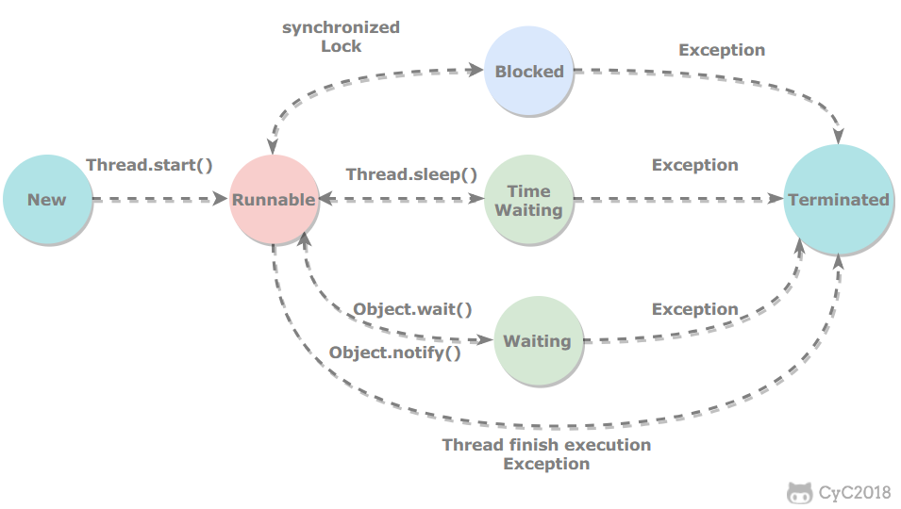

New
It has not started since creation.

Runnable
Whether it is running or it is waiting for a CPU time slice.
Contains Running and Ready in the operating system thread state.

Blocked
Waiting to acquire an exclusive lock, this state ends if its thread releases the lock.

Wait for other threads to explicitly wake up, otherwise no CPU time slice will be allocated.
Entry method | Exit method
Object.wait () method without setting the Timeout parameter | Object.notify() / Object.notifyAll()
Thread.join () method without setting the Timeout parameter | The called thread has finished executing
LockSupport.park () method | LockSupport.unpark(Thread)

Timed Waiting
There is no need to wait for other threads to wake up explicitly, it will be automatically awakened by the system after a certain time.
When calling Thread.sleep () method to put a thread into a waiting period, it is often described as "sleeping a thread".
When calling Object.wait () method to make a thread wait for a period of time or wait indefinitely, it is often described by "suspending a thread".
Sleep and suspend are used to describe behavior, while blocking and wait are used to describe state.
The difference between blocking and waiting is that blocking is passive, it is waiting to acquire an exclusive lock. Waiting is active and is entered by calling Thread.sleep () and Object.wait ().

Entry method | Exit method
Thread.sleep () method | time's up
Object.wait () method with Timeout parameter set | End of time / Object.notify () / Object.notifyAll ()
Thread.join () method with Timeout parameter set | End of time / The called thread has finished executing
LockSupport.parkNanos () method | LockSupport.unpark(Thread)
LockSupport.parkUntil () method | LockSupport.unpark(Thread)

（Terminated）
This can be after the thread finishes the task itself, or it ends with an exception.

Using threads
There are three ways to use threads:
- Implement the Runnable interface;
- Implement the Callable interface;
- Inherited from the Thread class.
A class that implements the Runnable and Callable interfaces can only be used as a task that can run in a thread, not a thread in the true sense, so it needs to be called through Thread in the end. It can be said that tasks are thread-driven.

Implementing the Runnable interface
You need to implement the run () method.
Start the thread by calling the start () method with Thread.
public class MyRunnable implements Runnable {
public void run () {
// ...
}
}
public static void main(String[] args) {
MyRunnable instance = new MyRunnable();
Thread thread = new Thread(instance);
thread.start();
}

Implementing the Callable interface
Compared with Runnable, Callable can have a return value, the return value is encapsulated by FutureTask.
public class MyCallable implements Callable<Integer> {
public Integer call() {
return 123;
}
}
public static void main(String[] args) throws ExecutionException, InterruptedException {
MyCallable mc = new MyCallable();
FutureTask<Integer> ft = new FutureTask<>(mc);
Thread thread = new Thread(ft);
thread.start();
System.out.println(ft.get());
}

Inherited from the Thread class
You also need to implement the run () method, because the Thread class also implements the Runnable interface.
When the start () method is called to start a thread, the virtual machine places the thread in the ready queue to be scheduled, and when a thread is scheduled, the run () method of the thread is executed.
public class MyThread extends Thread {
public void run() {
// ...
}
}
public static void main(String[] args) {
MyThread mt = new MyThread();
mt.start();
}

Implement interface vs inherit Thread
Implementing the interface would be better because:
- Java does not support multiple inheritance, so inheriting the Thread class cannot inherit other classes, but it can implement multiple interfaces;
- The class may only need to be executable, and inheriting the entire Thread class is too expensive.

Third, the basic thread mechanism

Executor
Executor manages the execution of multiple asynchronous tasks without requiring the programmer to explicitly manage the life cycle of the thread. Asynchronous here means that the execution of multiple tasks does not interfere with each other and does not require synchronous operations.
There are three main types of Executor:
- CachedThreadPool: one task creates one thread;
- FixedThreadPool: All tasks can only use fixed-size threads;
- SingleThreadExecutor: Equivalent to a FixedThreadPool of size 1.
public static void main(String[] args) {
ExecutorService executorService = Executors.newCachedThreadPool();
for (int i = 0; i < 5; i++) {
executorService.execute(new MyRunnable());
}
executorService.shutdown();
}

Daemon
Daemon threads are threads that provide services in the background while the program is running, and are not an integral part of the program.
When all non-daemon threads have ended, the program terminates and all daemon threads are killed.
main () belongs to a non-daemon thread.
Use the setDaemon () method to set a thread as a daemon thread before the thread starts.
public static void main(String[] args) {
Thread thread = new Thread(new MyRunnable());
thread.setDaemon(true);
}

sleep()
The Thread.sleep (millisec) method sleeps the currently executing thread. The millisec unit is milliseconds.
sleep () may throw an InterruptedException because the exception cannot be propagated back to main () across threads and must be handled locally. Other exceptions thrown in the thread also need to be handled locally.
public void run() {
try {
Thread.sleep(3000);
} catch (InterruptedException e) {
e . printStackTrace ();
}
}

yield()
The call to the static method Thread.yield () declares that the current thread has completed the most important part of its life cycle and can be switched to other threads for execution. This method is only a suggestion for the thread scheduler, and it is only recommended that other threads with the same priority can run.
public void run() {
Thread.yield();
}

Fourth, interrupt
A thread will automatically end after execution, and it will end early if an exception occurs during the run.

InterruptedException
Interrupt a thread by calling its interrupt (). If the thread is in a blocking, waiting, or waiting indefinitely state, an InterruptedException will be thrown, thus ending the thread early. However, I / O blocking and synchronized lock blocking cannot be interrupted.
For the following code, a thread is interrupted after it is started in main (). Because the Thread.sleep () method is called in the thread, an InterruptedException is thrown, so the thread is terminated in advance and the subsequent statements are not executed.
public class InterruptExample {

private static class MyThread1 extends Thread {
@Override
public void run() {
try {
Thread.sleep(2000);
System.out.println("Thread run");
} catch (InterruptedException e) {
e . printStackTrace ();
}
}
}
}
public static void main(String[] args) throws InterruptedException {
Thread thread1 = new MyThread1();
thread1.start();
thread1.interrupt();
System.out.println("Main run");
}
Main run
java.lang.InterruptedException: sleep interrupted
at java.lang.Thread.sleep(Native Method)
at InterruptExample.lambda$main$0(InterruptExample.java:5)
at InterruptExample$$Lambda$1/713338599.run(Unknown Source)
at java.lang.Thread.run(Thread.java:745)

interrupted()
If a thread's run () method executes an infinite loop and does not perform operations such as sleep () that would throw an InterruptedException, then calling the thread's interrupt () method will not cause the thread to end prematurely.
But calling the interrupt () method will set the thread's interrupt flag, and calling the interrupted () method will return true at this time. Therefore, you can use the interrupted () method in the loop body to determine whether the thread is in the interrupted state, thereby ending the thread early.
public class InterruptExample {

private static class MyThread2 extends Thread {
@Override
public void run() {
while (!interrupted()) {
// ..
}
System.out.println("Thread end");
}
}
}
public static void main(String[] args) throws InterruptedException {
Thread thread2 = new MyThread2();
thread2.start();
thread.interrupt();
}
Thread end

Executor interrupt operation
Calling the shutdown () method of Executor will wait for the threads to finish executing before closing, but if the shutdownNow () method is called, it is equivalent to calling the interrupt () method of each thread.
The following uses Lambda to create a thread, which is equivalent to creating an anonymous internal thread.
public static void main(String[] args) {
ExecutorService executorService = Executors.newCachedThreadPool();
executorService.execute(() -> {
try {
Thread.sleep(2000);
System.out.println("Thread run");
} catch (InterruptedException e) {
e . printStackTrace ();
}
});
executorService.shutdownNow();
System.out.println("Main run");
}
Main run
java.lang.InterruptedException: sleep interrupted
at java.lang.Thread.sleep(Native Method)
at ExecutorInterruptExample.lambda$main$0(ExecutorInterruptExample.java:9)
at ExecutorInterruptExample$$Lambda$1/1160460865.run(Unknown Source)
at java.util.concurrent.ThreadPoolExecutor.runWorker(ThreadPoolExecutor.java:1142)
at java.util.concurrent.ThreadPoolExecutor$Worker.run(ThreadPoolExecutor.java:617)
at java.lang.Thread.run(Thread.java:745)
If you only want to interrupt one thread in the Executor, you can submit a thread by using the submit () method, which will return a Future <?> Object, which can be interrupted by calling the cancel (true) method of the object.
Future<?> future = executorService.submit(() -> {
// ..
});
future.cancel(true);

Five, mutually exclusive synchronization
Java provides two lock mechanisms to control mutual access to shared resources by multiple threads. The first is synchronized by the JVM and the other is ReentrantLock by the JDK.

synchronized
Synchronize a code block
public void func() {
synchronized (this) {
// ...
}
}
It only works on the same object. If you call a synchronization code block on two objects, it will not be synchronized.
For the following code, two threads are executed using the ExecutorService. Because the synchronization code block of the same object is called, the two threads will synchronize. When one thread enters the synchronization statement block, the other thread must wait.
public class SynchronizedExample {

public void func1() {
synchronized (this) {
for (int i = 0; i < 10; i++) {
System.out.print(i + " ");
}
}
}
}
public static void main(String[] args) {
SynchronizedExample e1 = new SynchronizedExample();
ExecutorService executorService = Executors.newCachedThreadPool();
executorService.execute(() -> e1.func1());
executorService.execute(() -> e1.func1());
}
0 1 2 3 4 5 6 7 8 9 0 1 2 3 4 5 6 7 8 9
For the following code, two threads call synchronization code blocks of different objects, so the two threads do not need to be synchronized. As can be seen from the output, the two threads are executed crosswise.
public static void main(String[] args) {
SynchronizedExample e1 = new SynchronizedExample();
SynchronizedExample e2 = new SynchronizedExample();
ExecutorService executorService = Executors.newCachedThreadPool();
executorService.execute(() -> e1.func1());
executorService.execute(() -> e2.func1());
}
0 0 1 1 2 2 3 3 4 4 5 5 6 6 7 7 8 8 9 9
2. Synchronize a method
public synchronized void func () {
// ...
}
It works on the same object as a synchronous code block.
3. Synchronize a Class
public void func() {
synchronized (SynchronizedExample.class) {
// ...
}
}
Acting on the entire class, that is, two threads calling this type of synchronization statement on different objects of the same class will also be synchronized.
public class SynchronizedExample {

public void func2() {
synchronized (SynchronizedExample.class) {
for (int i = 0; i < 10; i++) {
System.out.print(i + " ");
}
}
}
}
public static void main(String[] args) {
SynchronizedExample e1 = new SynchronizedExample();
SynchronizedExample e2 = new SynchronizedExample();
ExecutorService executorService = Executors.newCachedThreadPool();
executorService.execute(() -> e1.func2());
executorService.execute(() -> e2.func2());
}
0 1 2 3 4 5 6 7 8 9 0 1 2 3 4 5 6 7 8 9
4. Synchronize a static method
public synchronized static void fun() {
// ...
}
Acts on the entire class.

ReentrantLock
ReentrantLock is a lock in the java.util.concurrent (JUC) package.
public class LockExample {

private Lock lock = new ReentrantLock();

public void func () {
lock.lock();
try {
for (int i = 0; i < 10; i++) {
System.out.print(i + " ");
}
} finally {
lock . unlock (); // Ensure that the lock is released to avoid deadlocks.
}
}
}
public static void main(String[] args) {
LockExample lockExample = new LockExample();
ExecutorService executorService = Executors.newCachedThreadPool();
executorService.execute(() -> lockExample.func());
executorService.execute(() -> lockExample.func());
}
0 1 2 3 4 5 6 7 8 9 0 1 2 3 4 5 6 7 8 9

Compare
Implementation of lock
synchronized is implemented by the JVM and ReentrantLock is implemented by the JDK.
Performance
The new version of Java has a lot of optimizations for synchronized, such as spin locks, etc. The synchronized and ReentrantLock are roughly the same.
3. Wait for interruption
When the thread holding the lock does not release the lock for a long time, the waiting thread can choose to give up waiting and handle other things instead.
ReentrantLock is interruptible, while synchronized is not.
Fair lock
A fair lock means that when multiple threads are waiting for the same lock, they must acquire the locks in order according to the chronological order of applying for the lock.
Locks in synchronized are unfair. ReentrantLock is also unfair by default, but it can also be fair.
5. Lock binding multiple conditions
A ReentrantLock can bind multiple Condition objects at the same time.

Use selection
Unless advanced features of ReentrantLock are needed, synchronized is preferred. This is because synchronized is a locking mechanism implemented by the JVM, which is natively supported by the JVM, and ReentrantLock is not supported by all JDK versions. And you don't need to worry about the deadlock caused by not releasing the lock, because the JVM will ensure the release of the lock.

Collaboration between threads
When multiple threads can work together to solve a problem, if some parts must be completed before others, then the threads need to be coordinated.

join()
Calling the join () method of another thread in a thread will suspend the current thread instead of waiting until the target thread ends.
For the following code, although the b thread is started first, because the join () method of the a thread is called in the b thread, the b thread will wait for the end of the a thread before continuing to execute, so it can be guaranteed that the output of the a thread precedes the Output.
public class JoinExample {

private class A extends Thread {
@Override
public void run() {
System.out.println("A");
}
}

private class B extends Thread {

private A a;

B(A a) {
this.a = a;
}

@Override
public void run() {
try {
a.join();
} catch (InterruptedException e) {
e . printStackTrace ();
}
System.out.println("B");
}
}

public void test() {
A a = new A();
B b = new B(a);
b.start();
a.start();
}
}
public static void main(String[] args) {
JoinExample example = new JoinExample();
example.test();
}
A
B

wait() , notify() , notifyAll()
Calling wait () causes the thread to wait for a certain condition to be met, and the thread is suspended while waiting. When other threads run to make this condition satisfy, other threads will call notify () or notifyAll () to wake up the suspended thread.
They are all part of Object, not Thread.
Can only be used in synchronous methods or synchronous control blocks, otherwise IllegalMonitorStateException will be thrown at runtime.
During a suspend using wait (), the thread releases the lock. This is because if the lock is not released, other threads cannot enter the synchronization method or synchronization control block of the object, and then notify () or notifyAll () cannot be executed to wake up the suspended thread, causing a deadlock.
public class WaitNotifyExample {

public synchronized void before() {
System.out.println("before");
notifyAll();
}

public synchronized void after() {
try {
wait();
} catch (InterruptedException e) {
e . printStackTrace ();
}
System.out.println("after");
}
}
public static void main(String[] args) {
ExecutorService executorService = Executors.newCachedThreadPool();
WaitNotifyExample example = new WaitNotifyExample();
executorService.execute(() -> example.after());
executorService.execute(() -> example.before());
}
before
after
The difference between wait () and sleep ()
- wait () is a method of Object, and sleep () is a static method of Thread;
- wait () will release the lock, sleep () will not.

await() signal() signalAll()
The java.util.concurrent class library provides the Condition class to achieve coordination between threads. You can call the await () method on Condition to make the thread wait, and other threads call the signal () or signalAll () method to wake up the waiting thread.
Compared to wait (), await () can be more flexible because it can specify conditions for waiting.
Use Lock to get a Condition object.
public class AwaitSignalExample {

private Lock lock = new ReentrantLock();
private Condition condition = lock.newCondition();

public void before() {
lock.lock();
try {
System.out.println("before");
condition.signalAll();
} finally {
lock.unlock();
}
}

public void after() {
lock.lock();
try {
condition.await();
System.out.println("after");
} catch (InterruptedException e) {
e . printStackTrace ();
} finally {
lock.unlock();
}
}
}
public static void main(String[] args) {
ExecutorService executorService = Executors.newCachedThreadPool();
AwaitSignalExample example = new AwaitSignalExample();
executorService.execute(() -> example.after());
executorService.execute(() -> example.before());
}
before
after

J.U.C - AQS
java.util.concurrent (JUC) greatly improves concurrency performance, and AQS is considered the core of JUC.

CountDownLatch
Used to control one or more threads waiting for multiple threads.
A counter cnt is maintained. Each time the countDown () method is called, the counter value is decremented by 1. When the counter is decremented to 0, those threads that are waiting due to calling the await () method will be woken up.
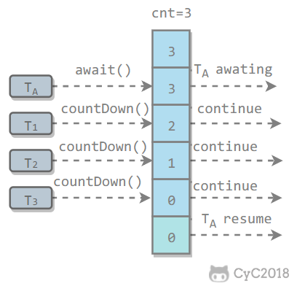

public class CountdownLatchExample {

public static void main(String[] args) throws InterruptedException {
final int totalThread = 10;
CountDownLatch countDownLatch = new CountDownLatch(totalThread);
ExecutorService executorService = Executors.newCachedThreadPool();
for (int i = 0; i < totalThread; i++) {
executorService.execute(() -> {
System.out.print("run..");
countDownLatch.countDown();
});
}
countDownLatch.await();
System.out.println("end");
executorService.shutdown();
}
}
Run..run..run..run..run..run..run..run..run..run..end

CyclicBarrier
It is used to control multiple threads to wait for each other. Only when multiple threads arrive, these threads will continue to execute.
Similar to CountdownLatch, both are implemented by maintaining counters. After the thread executes the await () method, the counter is decremented by 1 and waits until the counter is 0. All threads that are waiting while calling the await () method cannot continue execution.
One difference between CyclicBarrier and CountdownLatch is that the counter of CyclicBarrier can be recycled by calling the reset () method, so it is called a circular barrier.
CyclicBarrier has two constructors, where parties indicates the initial value of the counter, and the barrierAction will be executed once when all threads reach the barrier.
public CyclicBarrier(int parties, Runnable barrierAction) {
if (parties <= 0) throw new IllegalArgumentException();
this.parties = parties;
this.count = parties;
this.barrierCommand = barrierAction;
}

public CyclicBarrier(int parties) {
this(parties, null);
}
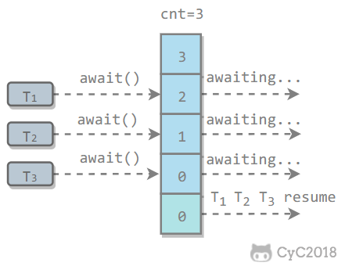

public class CyclicBarrierExample {

public static void main(String[] args) {
final int totalThread = 10;
CyclicBarrier cyclicBarrier = new CyclicBarrier(totalThread);
ExecutorService executorService = Executors.newCachedThreadPool();
for (int i = 0; i < totalThread; i++) {
executorService.execute(() -> {
System.out.print("before..");
try {
cyclicBarrier.await();
} catch (InterruptedException | BrokenBarrierException e) {
e . printStackTrace ();
}
System.out.print("after..");
});
}
executorService.shutdown();
}
}
before..before..before..before..before..before..before..before..before..before..after..after..after..after..after..after..after..after..after..after..

Semaphore
Semaphore is similar to a semaphore in the operating system and controls the number of threads accessing a mutex.
The following code simulates a concurrent request for a service. Only 3 clients can access it at a time, and the total number of requests is 10.
public class SemaphoreExample {

public static void main(String[] args) {
final int clientCount = 3;
final int totalRequestCount = 10;
Semaphore semaphore = new Semaphore(clientCount);
ExecutorService executorService = Executors.newCachedThreadPool();
for (int i = 0; i < totalRequestCount; i++) {
executorService.execute(()->{
try {
semaphore.acquire();
System.out.print(semaphore.availablePermits() + " ");
} catch (InterruptedException e) {
e . printStackTrace ();
} finally {
semaphore.release();
}
});
}
executorService.shutdown();
}
}
2 1 2 2 2 2 2 1 2 2

Eight, JUC-other components

FutureTask
When we introduced Callable, we knew that it could have a return value, and the return value was encapsulated by Future. FutureTask implements the RunnableFuture interface, which inherits from the Runnable and Future interfaces. This allows FutureTask to be executed as a task and can also have a return value.
public class FutureTask<V> implements RunnableFuture<V>
public interface RunnableFuture<V> extends Runnable, Future<V>
FutureTask can be used in the scenario where the execution result is obtained asynchronously or the task is cancelled. When a computing task takes a long time to execute, you can use FutureTask to encapsulate this task, and the main thread will obtain the results after completing its own task.
public class FutureTaskExample {

public static void main(String[] args) throws ExecutionException, InterruptedException {
FutureTask<Integer> futureTask = new FutureTask<Integer>(new Callable<Integer>() {
@Override
public Integer call() throws Exception {
int result = 0;
for (int i = 0; i < 100; i++) {
Thread.sleep(10);
result += i;
}
return result;
}
});

Thread computeThread = new Thread(futureTask);
computeThread.start();

Thread otherThread = new Thread(() -> {
System.out.println("other task is running...");
try {
Thread.sleep(1000);
} catch (InterruptedException e) {
e . printStackTrace ();
}
});
otherThread.start();
System.out.println(futureTask.get());
}
}
other task is running...
4950

BlockingQueue
The java.util.concurrent.BlockingQueue interface has the following implementations of blocking queues:
- FIFO queue : LinkedBlockingQueue, ArrayBlockingQueue (fixed length)
- Priority queue : PriorityBlockingQueue
Provides blocking take () and put () methods: if the queue is empty take () will block until there is content in the queue; if the queue is full, put () will block until the queue has a free position.
Implementing producer and consumer issues with BlockingQueue
public class ProducerConsumer {

private static BlockingQueue<String> queue = new ArrayBlockingQueue<>(5);

private static class Producer extends Thread {
@Override
public void run() {
try {
queue.put("product");
} catch (InterruptedException e) {
e . printStackTrace ();
}
System.out.print("produce..");
}
}

private static class Consumer extends Thread {

@Override
public void run() {
try {
String product = queue.take();
} catch (InterruptedException e) {
e . printStackTrace ();
}
System.out.print("consume..");
}
}
}
public static void main(String[] args) {
for (int i = 0; i < 2; i++) {
Producer producer = new Producer();
producer.start();
}
for (int i = 0; i < 5; i++) {
Consumer consumer = new Consumer();
consumer.start();
}
for (int i = 0; i < 3; i++) {
Producer producer = new Producer();
producer.start();
}
}
produce..produce..consume..consume..produce..consume..produce..consume..produce..consume..

ForkJoin
It is mainly used in parallel computing. Similar to MapReduce, it divides large computing tasks into multiple small tasks for parallel computing.
public class ForkJoinExample extends RecursiveTask<Integer> {

private final int threshold = 5;
private int first;
private int last;

public ForkJoinExample(int first, int last) {
this.first = first;
this.last = last;
}

@Override
protected Integer compute () {
int result = 0 ;
if (last - first <= threshold) {
// The task is small enough to calculate directly
for ( int i = first; i <= last; i ++ ) {
result += i;
}
} else {
// 拆分成小任务
int middle = first + (last - first) / 2;
ForkJoinExample leftTask = new ForkJoinExample(first, middle);
ForkJoinExample rightTask = new ForkJoinExample(middle + 1, last);
leftTask.fork();
rightTask.fork();
result = leftTask.join() + rightTask.join();
}
return result;
}
}
public static void main(String[] args) throws ExecutionException, InterruptedException {
ForkJoinExample example = new ForkJoinExample(1, 10000);
ForkJoinPool forkJoinPool = new ForkJoinPool();
Future result = forkJoinPool.submit(example);
System.out.println(result.get());
}
ForkJoin is started using ForkJoinPool, which is a special thread pool. The number of threads depends on the number of CPU cores.
public class ForkJoinPool extends AbstractExecutorService
ForkJoinPool implements a work stealing algorithm to improve CPU utilization. Each thread maintains a double-ended queue to store tasks that need to be executed. The work stealing algorithm allows an idle thread to steal a task from a double-ended queue of other threads for execution. The stolen task must be the latest task to avoid competition with the thread to which the queue belongs. For example, in the following figure, Thread2 takes the latest Task1 task from Thread1's queue, and Thread1 takes Task2 for execution, so as to avoid competition. But if there is only one task in the queue, competition will still occur.
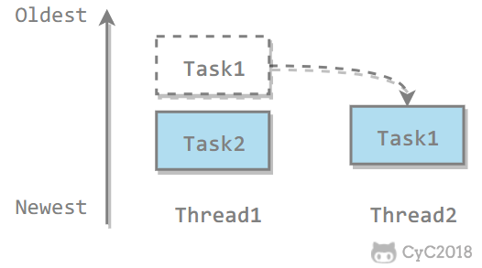

Nine, thread unsafe example
If multiple threads access the same shared data without taking a synchronous operation, the results of the operation are inconsistent.
The following code demonstrates that 1000 threads perform an increment operation on cnt at the same time. After the operation, its value may be less than 1000.
public class ThreadUnsafeExample {

private int cnt = 0;

public void add () {
cnt++;
}

public int get() {
return cnt;
}
}
public static void main(String[] args) throws InterruptedException {
final int threadSize = 1000;
ThreadUnsafeExample example = new ThreadUnsafeExample();
final CountDownLatch countDownLatch = new CountDownLatch(threadSize);
ExecutorService executorService = Executors.newCachedThreadPool();
for (int i = 0; i < threadSize; i++) {
executorService.execute(() -> {
example.add();
countDownLatch.countDown();
});
}
countDownLatch.await();
executorService.shutdown();
System.out.println(example.get());
}
997

Ten, the Java memory model
The Java memory model attempts to shield the memory access differences of various hardware and operating systems, so that Java programs can achieve consistent memory access effects on various platforms.

Main memory and working memory
Registers on the processor can be read and written several orders of magnitude faster than memory. To resolve this speed conflict, a cache is added between them.
Joining the cache brings a new problem: cache coherence. If multiple caches share the same main memory area, the data of multiple caches may be inconsistent, and some protocols are required to solve this problem.
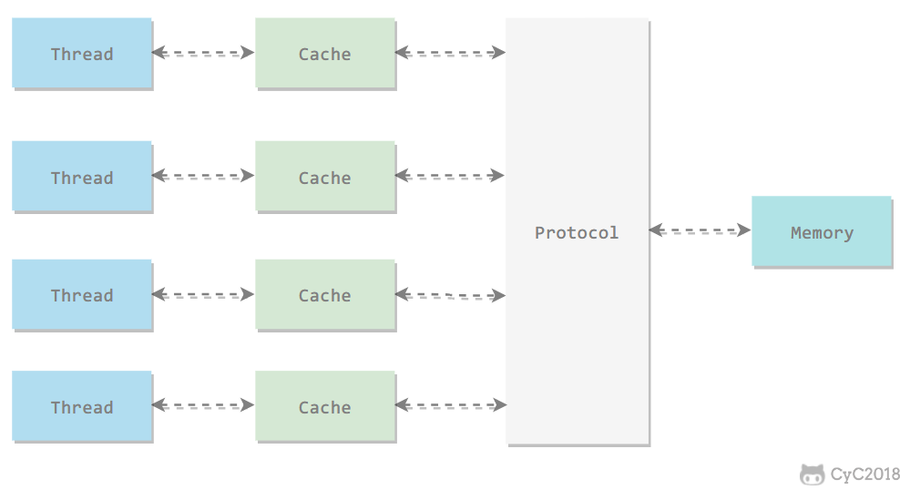

All variables are stored in main memory, and each thread also has its own working memory. The working memory is stored in a cache or register, which holds a copy of the main memory copy of the variables used by the thread.
Threads can only directly manipulate variables in working memory, and the transfer of variable values ​​between different threads needs to be done through main memory.
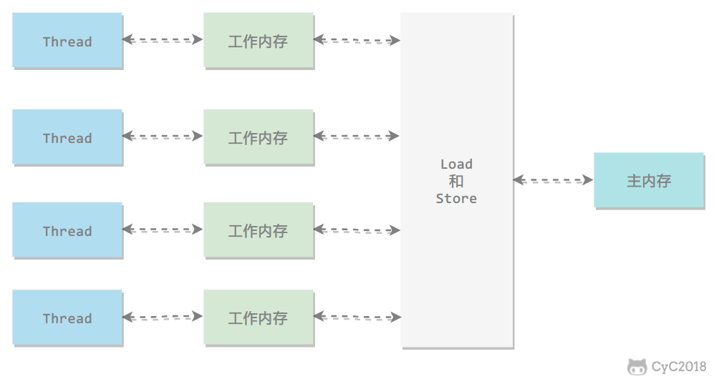

Inter-memory interaction
The Java memory model defines eight operations to complete the interaction of main memory and working memory.
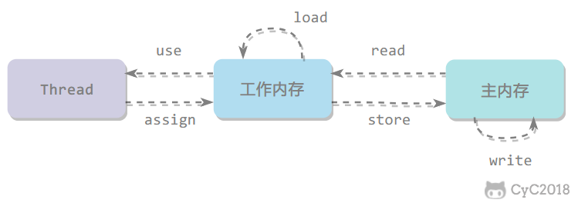

- read: transfer the value of a variable from main memory to working memory
- load: Execute after read, put the value read into the variable copy of working memory
- use: pass the value of a variable in working memory to the execution engine
- assign: assign a value received from the execution engine to a variable in working memory
- store: transfer the value of a variable in working memory to main memory
- write: execute after store, put the value from store into a variable in main memory
- lock: Variables acting on main memory
- unlock

Three characteristics of the memory model

Atomicity
The Java memory model guarantees that the read, load, use, assign, store, write, lock, and unlock operations are atomic, such as performing an assignment operation on a variable of type int. This operation is atomic. However, the Java memory model allows the virtual machine to divide read and write operations of 64-bit data (long, double) that are not modified by volatile into two 32-bit operations, that is, the load, store, read, and write operations may not be atomic. .
There is a misunderstanding that atomic types such as int do not have thread safety issues in a multithreaded environment. In the previous thread-unsafe example code, cnt is an int type variable, and after 1000 threads increment it, the value is 997 instead of 1000.
In order to facilitate the discussion, the interaction between memory is simplified into three: load, assign, store.
The following figure demonstrates that two threads operate on cnt at the same time. The series of operations such as load, assign, and store are not atomic. As a result, cnt is modified at T1 and the modified value has not been written to main memory. Can read in old values. It can be seen that although these two threads have performed two increment operations, the value of cnt in main memory ends up being 1 instead of 2. Therefore, satisfying atomicity for read and write operations of int type only indicates that the individual operations of load, assign, and store are atomic.
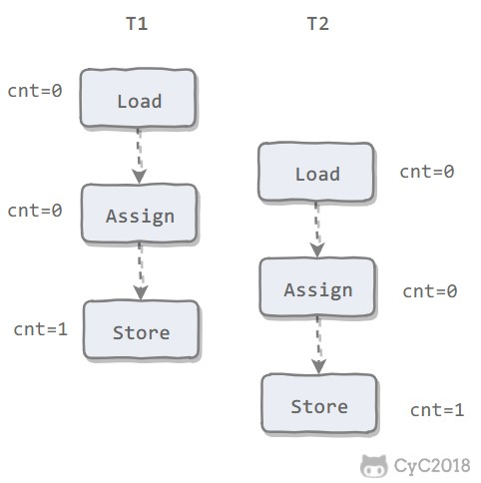

AtomicInteger guarantees the atomicity of multiple thread modifications.
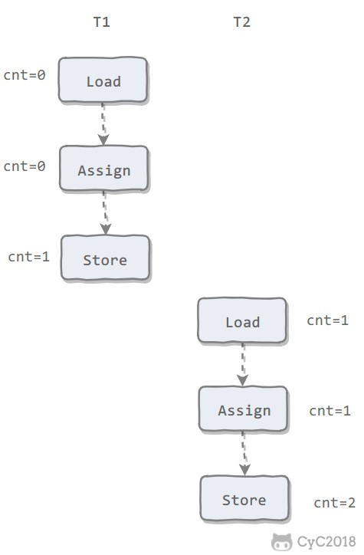

After using AtomicInteger to rewrite previously thread-unsafe code, I get the following thread-safe implementation:
public class AtomicExample {
private AtomicInteger cnt = new AtomicInteger();

public void add () {
cnt . incrementAndGet ();
}

public int get() {
return cnt.get();
}
}
public static void main(String[] args) throws InterruptedException {
final int threadSize = 1000;
AtomicExample example = new AtomicExample(); // 只修改这条语句
final CountDownLatch countDownLatch = new CountDownLatch(threadSize);
ExecutorService executorService = Executors.newCachedThreadPool();
for (int i = 0; i < threadSize; i++) {
executorService.execute(() -> {
example.add();
countDownLatch.countDown();
});
}
countDownLatch.await();
executorService.shutdown();
System.out.println(example.get());
}
1000
In addition to using atomic classes, you can also use synchronized mutex to ensure atomicity of operations. The corresponding memory-to-memory interactions are: lock and unlock, and the corresponding bytecode instructions on the virtual machine implementation are monitorenter and monitorexit.
public class AtomicSynchronizedExample {
private int cnt = 0;

public synchronized void add() {
cnt++;
}

public synchronized int get() {
return cnt;
}
}
public static void main(String[] args) throws InterruptedException {
final int threadSize = 1000;
AtomicSynchronizedExample example = new AtomicSynchronizedExample();
final CountDownLatch countDownLatch = new CountDownLatch(threadSize);
ExecutorService executorService = Executors.newCachedThreadPool();
for (int i = 0; i < threadSize; i++) {
executorService.execute(() -> {
example.add();
countDownLatch.countDown();
});
}
countDownLatch.await();
executorService.shutdown();
System.out.println(example.get());
}
1000

Visibility
Visibility means that when a thread changes the value of a shared variable, other threads can immediately learn about the change. The Java memory model achieves visibility by synchronizing the new value back to main memory after the variable is modified, and refreshing the variable value from main memory before the variable is read.
There are three main ways to achieve visibility:
- volatile
- synchronized. Before performing an unlock operation on a variable, the variable value must be synchronized back to main memory.
- final, once the field modified by the final keyword is initialized in the constructor and this escape does not occur (other threads access the half-initialized object through this reference), then other threads can see the value of the final field.
Using the volatile decoration on the cnt variable in the previous thread-unsafe example cannot solve the thread-unsafe problem, because volatile does not guarantee the atomicity of operations.

Orderly
Orderness means: Observe in this thread that all operations are in order. When one thread observes another thread, all operations are out of order. Out of order is because of instruction reordering. In the Java memory model, the compiler and processor are allowed to reorder instructions. The reordering process does not affect the execution of single-threaded programs, but it affects the correctness of multi-threaded concurrent execution.
The volatile keyword prohibits instruction reordering by adding a memory barrier, that is, you cannot place subsequent instructions before the memory barrier during reordering.
You can also ensure synchronization by synchronizing, which guarantees that only one thread executes synchronous code at a time, which is equivalent to letting threads execute synchronous code in sequence.

Antecedent principle
As mentioned above, you can use volatile and synchronized to ensure ordering. In addition, the JVM also specifies the preemptive principle, which allows one operation to complete before another operation without control.

Single thread principle
Single Thread rule
In a thread, operations that precede the program occur before operations that follow.
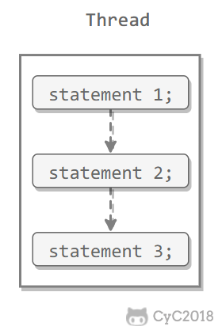

2. Process lock rules
Monitor Lock Rule
An unlock operation precedes a subsequent lock operation on the same lock.
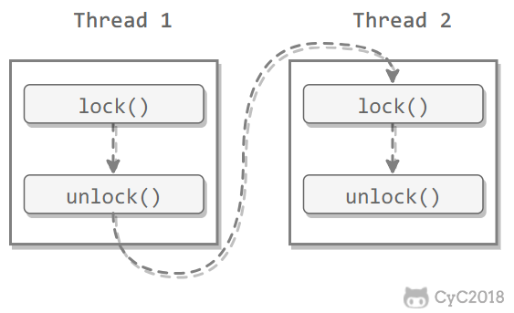

3. volatile variable rules
Volatile Variable Rule
A write operation to a volatile variable occurs before a subsequent read operation to this variable.
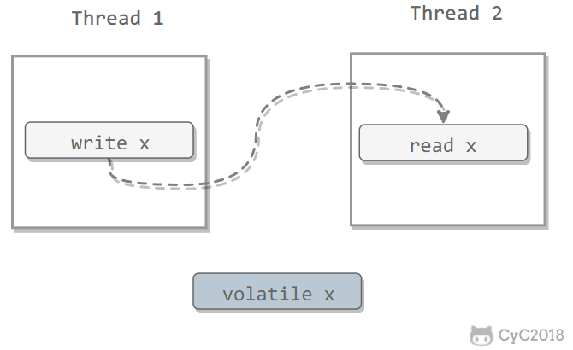

4. Thread startup rules
Thread Start Rule
The start () method call of the Thread object precedes every action that occurs on this thread.
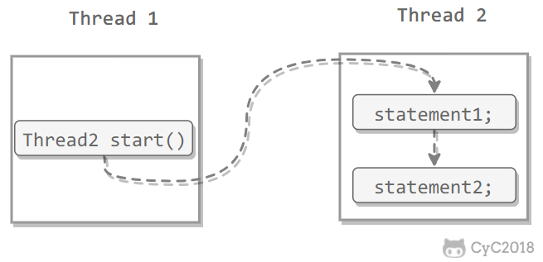

5. Thread Join Rule
Thread Join Rule
The end of the Thread object first occurs when the join () method returns.
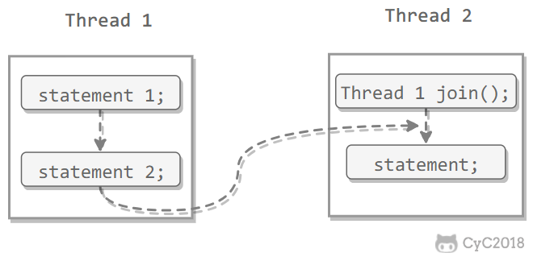

6. Thread interruption rules
Thread Interruption Rule
The call to the thread's interrupt () method first occurs when the interrupted thread's code detects the occurrence of an interrupt event, and the interrupted () method can be used to detect whether an interrupt has occurred.

7. Object termination rules
Finalizer Rule
The completion of an object's initialization (the end of the constructor's execution) occurs before the start of its finalize () method.

8. Transitivity
Transitivity
If operation A precedes operation B and operation B precedes operation C, then operation A precedes operation C.

Eleven, thread safety
No matter how a thread accesses a class and does not need to be synchronized in the calling code, it can behave correctly.
There are several ways to achieve thread safety:

Immutable
Immutable objects must be thread-safe, and no thread-safety measures need to be taken. As long as an immutable object is constructed correctly, you will never see it in an inconsistent state among multiple threads. In a multi-threaded environment, objects should be made as immutable as possible to meet thread safety.
Immutable types:
- basic data type decorated with final keyword
- String
- Enumerated type
- Number subclasses, such as numeric wrap types such as Long and Double, and big data types such as BigInteger and BigDecimal. But atomic classes AtomicInteger and AtomicLong, which are also Number, are mutable.
For collection types, you can use the Collections.unmodifiableXXX () methods to get an immutable collection.
public class ImmutableExample {
public static void main(String[] args) {
Map<String, Integer> map = new HashMap<>();
Map<String, Integer> unmodifiableMap = Collections.unmodifiableMap(map);
unmodifiableMap.put("a", 1);
}
}
Exception in thread "main" java.lang.UnsupportedOperationException
at java.util.Collections$UnmodifiableMap.put(Collections.java:1457)
at ImmutableExample.main(ImmutableExample.java:9)
Collections.unmodifiableXXX () copies the original collection first, and all methods that need to modify the collection directly throw exceptions.
public V put(K key, V value) {
throw new UnsupportedOperationException();
}

Mutex synchronization
synchronized 和 ReentrantLock。

Non-blocking synchronization
The main problem with mutex synchronization is the performance problem caused by thread blocking and wakeup, so this kind of synchronization is also called blocking synchronization.
Mutual exclusion synchronization is a pessimistic concurrency strategy. It is always believed that as long as the correct synchronization measures are not taken, problems will definitely occur. Regardless of whether shared data will really compete, it must be locked (the conceptual model discussed here, in fact, the virtual machine optimizes a large part of unnecessary locks), user-mode core state transitions, maintaining lock counters and Check if there are any blocked threads that need to wake up.
With the development of the hardware instruction set, we can use an optimistic concurrency strategy based on conflict detection: perform the operation first, if there are no other threads competing for shared data, the operation is successful, otherwise compensation measures are taken (continuously retrying until successful until). Many implementations of this optimistic concurrency strategy do not need to block threads, so this synchronization operation is called non-blocking synchronization.

1. CAS
Optimistic locks require the two steps of operation and conflict detection to be atomic. Mutual exclusion synchronization can no longer be used to guarantee this. It can only be done by hardware. The most typical atomic operations supported by hardware are: Compare-and-Swap (CAS). The CAS instruction requires three operands, which are the memory address V, the old expected value A, and the new value B. When performing an operation, the value of V is updated to B only when the value of V is equal to A.

2. AtomicInteger
The AtomicInteger method of the integer atomic class in the JUC package calls the CAS operation of the Unsafe class.
The following code uses AtomicInteger to perform the auto-increment operation.
private AtomicInteger cnt = new AtomicInteger ();

public void add() {
cnt . incrementAndGet ();
}
The following code is the source of incrementAndGet (), which calls Unsafe's getAndAddInt ().
public final int incrementAndGet() {
return unsafe.getAndAddInt(this, valueOffset, 1) + 1;
}
The following code is the source code of getAndAddInt (), var1 indicates the object memory address, var2 indicates the offset of the field from the object memory address, and var4 indicates the value to be added for the operation, here is 1. GetIntVolatile (var1, var2) to get the old expected value, and call compareAndSwapInt () for CAS comparison. If the value in the field's memory address is equal to var5, then update the variable with memory address var1 + var2 to var5 + var4.
You can see that getAndAddInt () is performed in a loop, and the conflicting method is to continuously retry.
public final int getAndAddInt ( Object var1, long var2, int var4) {
int var5;
do {
var5 = this.getIntVolatile(var1, var2);
} while(!this.compareAndSwapInt(var1, var2, var5, var5 + var4));

return var5;
}

3. ABA
If the value of a variable is A when it is first read, its value is changed to B, and then it is changed back to A, then the CAS operation will mistakenly think that it has never been changed.
The JUC package provides a tagged atomic reference class AtomicStampedReference to solve this problem. It can guarantee the correctness of CAS by controlling the version of the variable value. In most cases, the ABA problem will not affect the correctness of the program concurrency. If you need to solve the ABA problem, it may be more efficient to use the traditional mutual exclusion synchronization than the atomic class.

No synchronization scheme
To be thread-safe, synchronization is not necessary. If a method does not involve sharing data, it naturally does not need any synchronization measures to ensure correctness.

Stack closed
When multiple threads access local variables of the same method, there is no thread safety problem, because local variables are stored in the virtual machine stack and belong to the thread private.
public class StackClosedExample {
public void add100() {
int cnt = 0;
for (int i = 0; i < 100; i++) {
cnt++;
}
System.out.println(cnt);
}
}
public static void main(String[] args) {
StackClosedExample example = new StackClosedExample();
ExecutorService executorService = Executors.newCachedThreadPool();
executorService.execute(() -> example.add100());
executorService.execute(() -> example.add100());
executorService.shutdown();
}
100
100

2. Thread Local Storage
If the data required in a piece of code must be shared with other code, then see if the code that shares the data can be guaranteed to execute in the same thread. If it can be guaranteed, we can limit the visible range of shared data to the same thread. In this way, there is no need for synchronization to ensure that data contention does not occur between threads.
Applications that meet this feature are not uncommon, and most architectural models that use consumer queues (such as the "producer-consumer" model) will consume the product's consumption process in one thread as much as possible. One of the most important application examples is the "Thread-per-Request" processing method in the classic Web interaction model. The wide application of this processing method makes many Web server applications can use threads Local storage to solve thread safety issues.
You can use the java.lang.ThreadLocal class to implement thread-local storage.
For the following code, threadLocal is set to 1 in thread1 and threadLocal is set to 2 in thread2. After a period of time, thread1 reads threadLocal is still 1, and is not affected by thread2.
public class ThreadLocalExample {
public static void main(String[] args) {
ThreadLocal threadLocal = new ThreadLocal();
Thread thread1 = new Thread(() -> {
threadLocal.set(1);
try {
Thread.sleep(1000);
} catch (InterruptedException e) {
e . printStackTrace ();
}
System.out.println(threadLocal.get());
threadLocal.remove();
});
Thread thread2 = new Thread(() -> {
threadLocal.set(2);
threadLocal.remove();
});
thread1.start();
thread2.start();
}
}
1
To understand ThreadLocal, first look at the following code:
public class ThreadLocalExample1 {
public static void main(String[] args) {
ThreadLocal threadLocal1 = new ThreadLocal();
ThreadLocal threadLocal2 = new ThreadLocal();
Thread thread1 = new Thread(() -> {
threadLocal1.set(1);
threadLocal2.set(1);
});
Thread thread2 = new Thread(() -> {
threadLocal1.set(2);
threadLocal2.set(2);
});
thread1.start();
thread2.start();
}
}
The corresponding underlying structure diagram is:
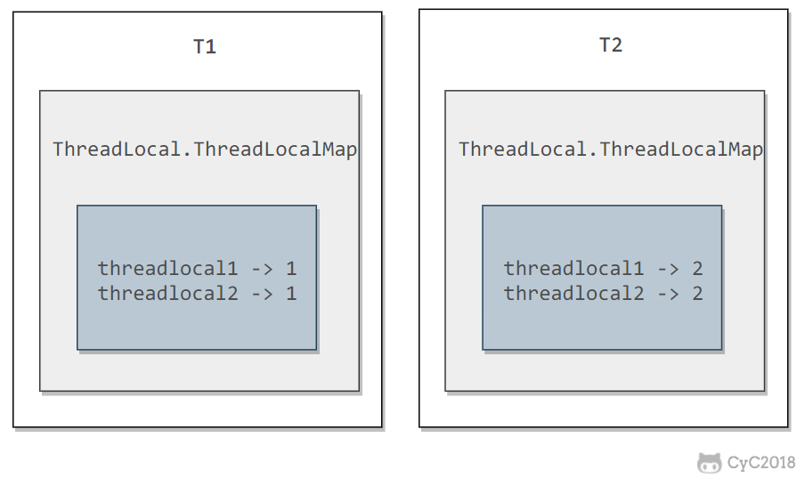

Each Thread has a ThreadLocal.ThreadLocalMap object.
/* ThreadLocal values pertaining to this thread. This map is maintained
* by the ThreadLocal class. */
ThreadLocal.ThreadLocalMap threadLocals = null;
When a set (T value) method of a ThreadLocal is called, the ThreadLocalMap object of the current thread is first obtained, and then the ThreadLocal-> value key-value pair is inserted into the Map.
public void set(T value) {
Thread t = Thread.currentThread();
ThreadLocalMap map = getMap(t);
if (map != null)
map.set(this, value);
else
createMap(t, value);
}
The get () method is similar.
public T get() {
Thread t = Thread.currentThread();
ThreadLocalMap map = getMap(t);
if (map != null) {
ThreadLocalMap.Entry e = map.getEntry(this);
if (e != null) {
@SuppressWarnings("unchecked")
T result = (T)e.value;
return result;
}
}
return setInitialValue();
}
ThreadLocal is not theoretically used to solve the multi-threaded concurrency problem, because there is no multi-threaded competition at all.
In some scenarios (especially using the thread pool), due to the underlying data structure of ThreadLocal.ThreadLocalMap, there is a memory leak in ThreadLocal. You should call remove () manually after using ThreadLocal whenever possible to avoid ThreadLocal classic memory Leaks are even a risk of disrupting your own business.

3. Reentrant Code
This code is also called Pure Code. It can be interrupted at any time during the execution of the code, and then execute another piece of code (including recursively calling itself). After the control returns, the original program will not appear. Any errors.
Reentrant code has some common characteristics, such as not relying on data stored on the heap and common system resources, the amount of state used is passed in as a parameter, and non-reentrant methods are not called.

Twelve, lock optimization
The lock optimization here mainly refers to the synchronization optimization of the JVM.

Spin lock
The overhead of mutex synchronization entering the blocking state is very large, and should be avoided as much as possible. In many applications, the locked state of shared data will only last for a short period of time. The idea of ​​a spin lock is to allow a thread to perform a busy loop (spin) for a period of time when requesting a lock for shared data. If a lock can be acquired during this time, you can avoid entering a blocking state.
Although the spin lock can avoid entering the blocking state and reduce the overhead, it requires busy loop operations to occupy CPU time. It is only suitable for scenarios where the locked state of shared data is short.
Adaptive spin locks were introduced in JDK 1.6. Adaptive means that the number of spins is no longer fixed, but is determined by the number of spins on the same lock and the state of the owner of the lock.

Lock elimination
Lock elimination refers to the elimination of locks on shared data where it is detected that there is no contention.
Lock elimination is mainly supported by escape analysis. If shared data on the heap cannot be escaped and accessed by other threads, then they can be treated as private data, and their locks can be eliminated.
For some code that does not appear to be locked, in fact, many locks are implicitly added. For example, the following string stitching code is implicitly locked:
public static String concatString(String s1, String s2, String s3) {
return s1 + s2 + s3;
}
String is an immutable class, and the compiler automatically optimizes String concatenation. Prior to JDK 1.5, continuous append () operations were converted to StringBuffer objects:
public static String concatString(String s1, String s2, String s3) {
StringBuffer sb = new StringBuffer();
sb.append(s1);
sb.append(s2);
sb.append(s3);
return sb.toString();
}
There is a sync block in each of the append () methods. The virtual machine observes the variable sb and soon finds that its dynamic scope is limited to the concatString () method. In other words, all references to sb will never escape outside the concatString () method, and other threads cannot access it, so they can be eliminated.

Lock coarsening
If a series of consecutive operations repeatedly lock and unlock the same object, frequent locking operations will cause performance loss.
This is the case for the continuous append () method in the sample code in the previous section. If the virtual machine detects that the same object is locked by such a series of fragmented operations, it will extend (roughen) the scope of the lock to the outside of the entire operation sequence. For the example code in the previous section, it extends to before the first append () operation and after the last append () operation, so you only need to lock it once.

Lightweight lock
JDK 1.6 introduced biased locks and lightweight locks, which allowed locks to have four states: unlocked, biasble, lightweight locked, and heavyweight locked ( inflated).
The following is the memory layout of the HotSpot virtual machine object head. This data is called Mark Word. The tag bits correspond to five states, which are given in the state table on the right. In addition to the marked for gc state, the other four states have been introduced earlier.
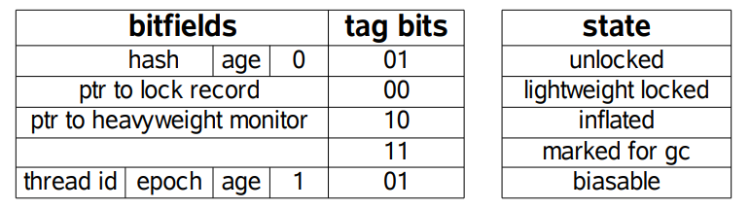

The left side of the figure below is a threaded virtual machine stack, a part of which is called the Lock Record area, which is created during the operation of the lightweight lock, and is used to store the Mark Word of the lock object. The right side is a lock object, which contains Mark Word and other information.
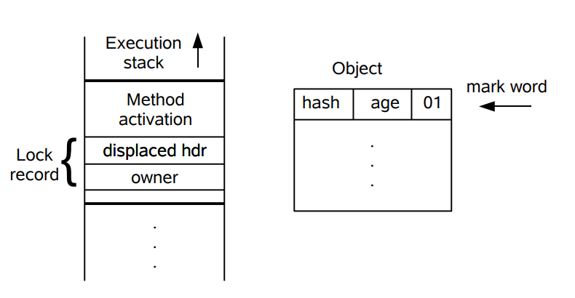

Lightweight locks use CAS operations to avoid the overhead of heavyweight locks using mutexes compared to traditional heavyweight locks. For most locks, there is no competition during the entire synchronization cycle, so there is no need to use the mutex for synchronization. You can use the CAS operation to synchronize first. If the CAS fails, use the mutex instead. Synchronize.
When trying to acquire a lock object, if the lock object is marked as 0 01, it indicates that the lock object is in an unlocked state. At this point, the virtual machine creates a Lock Record in the virtual machine stack of the current thread, and then uses the CAS operation to update the object's Mark Word to a Lock Record pointer. If the CAS operation succeeds, the thread acquires the lock on the object, and the lock mark of the object's Mark Word becomes 00, indicating that the object is in a lightweight lock state.
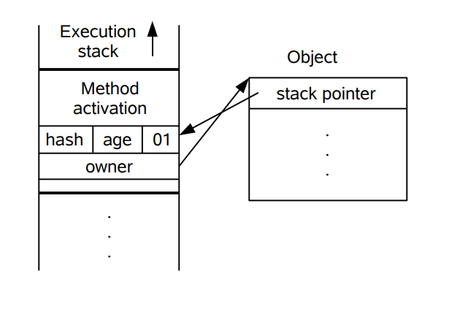

If the CAS operation fails, the virtual machine first checks whether the object's Mark Word points to the virtual machine stack of the current thread. If so, it indicates that the current thread already owns the lock object, then it can directly enter the synchronization block to continue execution, otherwise it indicates this. The lock object has been preempted by another thread. If there are more than two threads competing for the same lock, then the lightweight lock is no longer valid, and it will swell to a heavy lock.

Bias lock
The idea of ​​biased locks is to favor the first thread that acquires the lock object. This thread no longer needs to perform synchronous operations to acquire the lock, and even CAS operations are no longer needed.
When the lock object is acquired by the thread for the first time, it enters a biased state and is marked as 1 01. At the same time, the CAS operation is used to record the thread ID into Mark Word. If the CAS operation is successful, the thread does not need to perform any synchronization operation each time it enters the lock-related synchronization block in the future.
When another thread tries to acquire the lock object, the bias state is declared ended, at this time the Revoke Bias is restored to the unlocked state or the lightweight lock state.
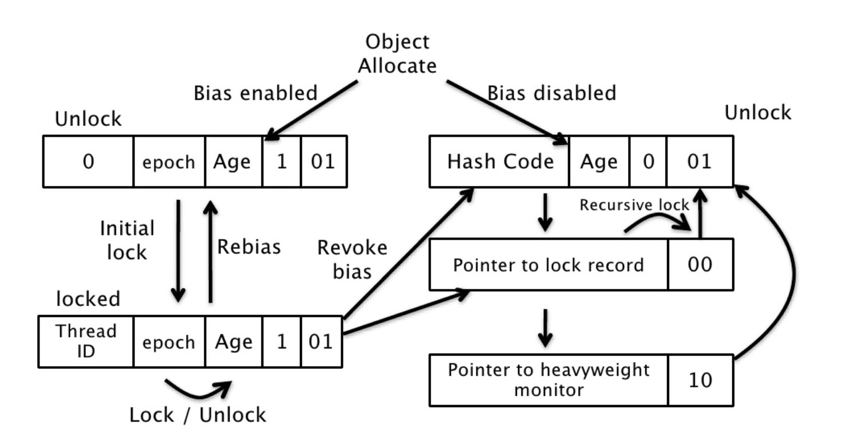

Thirteen, good practice in multithreaded development
- Give the thread a meaningful name so that you can easily find the bug.
- Reduce the scope of synchronization to reduce lock contention. For synchronization, for example, you should try to use synchronized blocks instead of synchronized methods.
- More synchronization tools use less wait () and notify (). First, the synchronization classes CountDownLatch, CyclicBarrier, Semaphore, and Exchanger simplify coding operations, and it is difficult to implement complex control flows with wait () and notify (). Second, these synchronization classes are written and maintained by the best companies. The JDK will continue to be optimized and improved.
- Use BlockingQueue to implement producer consumer issues.
- Use more concurrent collections and less synchronous collections. For example, you should use ConcurrentHashMap instead of Hashtable.
- Use local variables and immutable classes to ensure thread safety.
- Use a thread pool instead of creating threads directly because creating threads is expensive, and the thread pool can effectively utilize limited threads to start tasks.

🏋️ Hands On

📖 Keycloak Integration
Run keycloak on Docker:
Step 1: Start Docker engine (Docker Desktop)
Step 2: Run docker image
docker run -p 8080:8080 -e KC_BOOTSTRAP_ADMIN_USERNAME=admin -e KC_BOOTSTRAP_ADMIN_PASSWORD=admin quay.io/keycloak/keycloak:26.1.3 start-dev
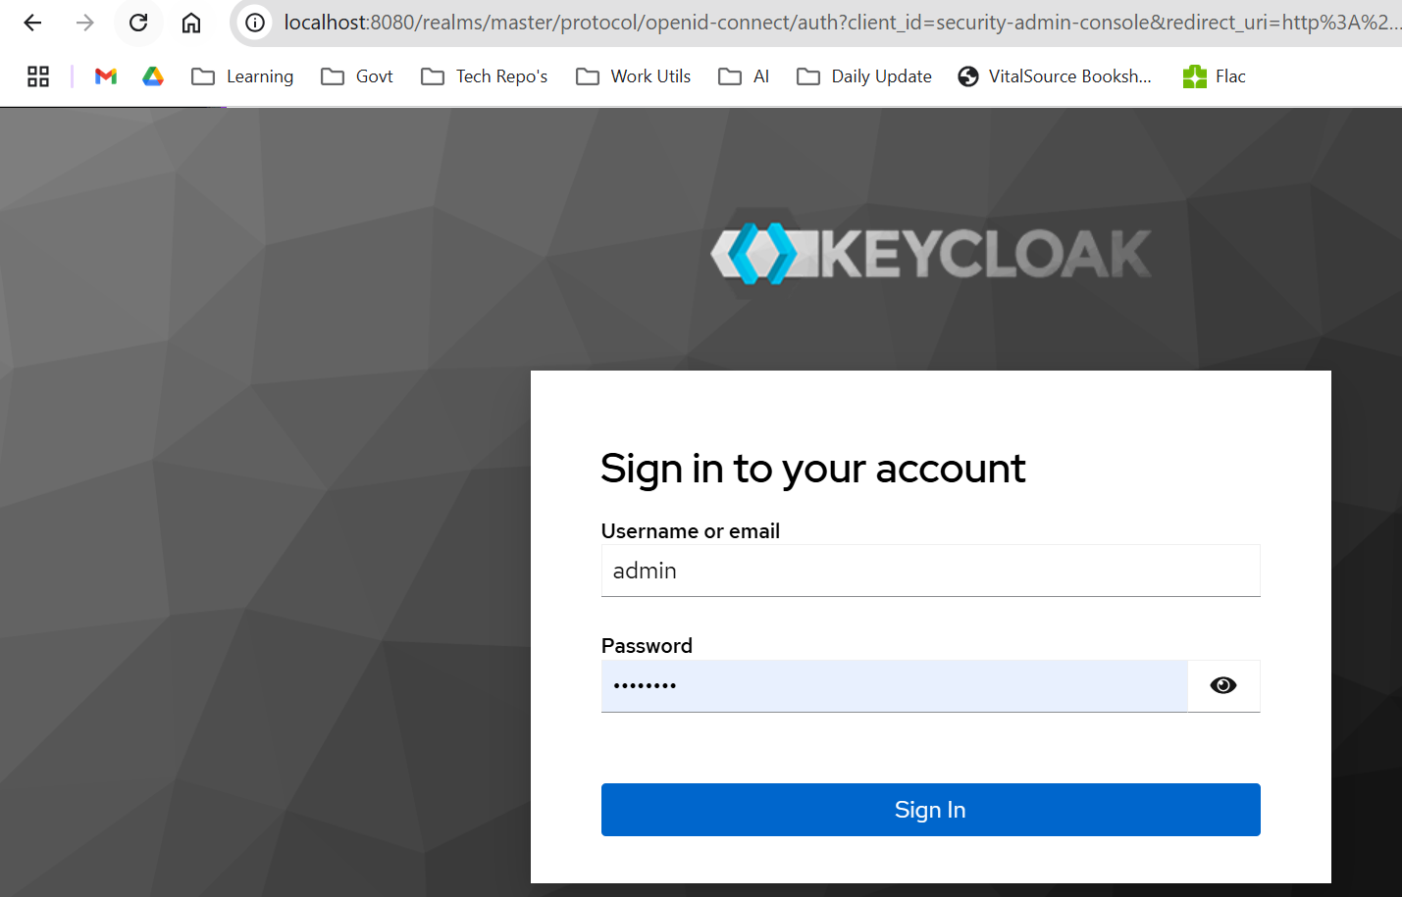

Realm:
Name - technotes
Realm is a set of clients. And based on the clients we can create a role
E.g.
Some client might be access from Public
Some client might be access form private(Intranet, service to service communication)

Create a Client:
oauth2-demo-private (Should access from private) enable Client authentication
oauth2-demo-public (Should access from public)

Default URL:
http://localhost:8080/login/oauth2/code/<client-name>

Client Secret:
Generate it

Create User:
Username - testuser1
Password - Test@123

MySql with Keycloak Integration
- Run Mysql Using Docker
  - docker pull mysql/mysql-server:8.0.28
  - docker run --name keycloak_db -d -e MYSQL_ROOT_PASSWORD='root' -p 3306:3306 mysql/mysql-server --skip-grant-tables
- Create keycloak database in MySQL
CREATE DATABASE keycloak_db CHARACTER SET utf8 COLLATE utf8_general_ci;
CREATE USER 'keycloak'@'%' IDENTIFIED BY 'admin';
GRANT ALL PRIVILEGES ON keycloak_db.* TO 'keycloak'@'%';
FLUSH PRIVILEGES;
- Bind keycloak docker into MySQL DB
docker run -p 8080:8080 \
-e KEYCLOAK_ADMIN=admin \
-e KEYCLOAK_ADMIN_PASSWORD=admin \
-e KC_DB=mysql \
-e KC_DB_URL=jdbc:mysql://localhost:3306/keycloak_db \
-e KC_DB_USERNAME=keycloak \
-e KC_DB_PASSWORD=password \
quay.io/keycloak/keycloak:latest start-dev

🏪 Git

📋 Configure two repositories in same machine
Generate SSH Key:
ssh-keygen -t rsa -b 4096 -C "rajendramani.r@gmail.com" -f ~/.ssh/id_rsa

If you don’t use the -f option, the program will prompt you to enter a filename. Above command will

Generate two keys:
Public key: ~/.ssh/id_rsa_github_personal.pub
Private key: ~/.ssh/id_rsa_github_personal
Copy the public key and configure it into GitHub and Gitlab.
xclip -sel clip < ~/.ssh/id_rsa.pub

Edit SSH file:
~/.ssh/config

📋 Git Stash
source ip= 172.31.80.60
smtp hostname= smtp2.convergeict.com
destinationip= 192.168.180.248
port number= 25

Conflict resolve:
Git stash:
git stash list
git stash push -m "Api-Signature"
git stash pop //Apply into current workspace

e.g.
$ git stash list
stash@{0}: WIP on stg-master: 9ffed21 added origin list changes
stash@{1}: On Dev-Drop1-Sprint10: Api-Signature

$ git stash drop 1
Dropped refs/stash@{1} (c93cf49f96faddf96c94dce2a5483173174eddea)
git stash drop

Get Payment details stash:
stash@{0}: WIP on DEV-HOBS-Master: 0213bea changes for get all product categories

After conflict resolve we need to commit the changes:

git add channels-integrations/src/main/java/com/cict/integrations/channelsintegrations/constants/BaaSConstants.java && git commit -m "resolve merge con

📋 Git Error - Unable to resolve reference
refs/remotes/origin/master reference broken

Answer 1:
You can fix this error by cleaning up your local repository.
git gc --prune=now

Additionally, you can also run,
git remote prune origin

Answer 2:
rm .git/refs/remotes/origin/master
git fetch
Then run git pull and it should work this time.

git pull
> Already up to date.
Note: Use the command for any branch that’s giving the error. For example, if I’m getting error for the main branch instead, I could do the following:

rm .git/refs/remotes/origin/main
git fetch

📋 error: cannot lock ref
git gc --prune=now

📋 Generate SSH key in windows 11

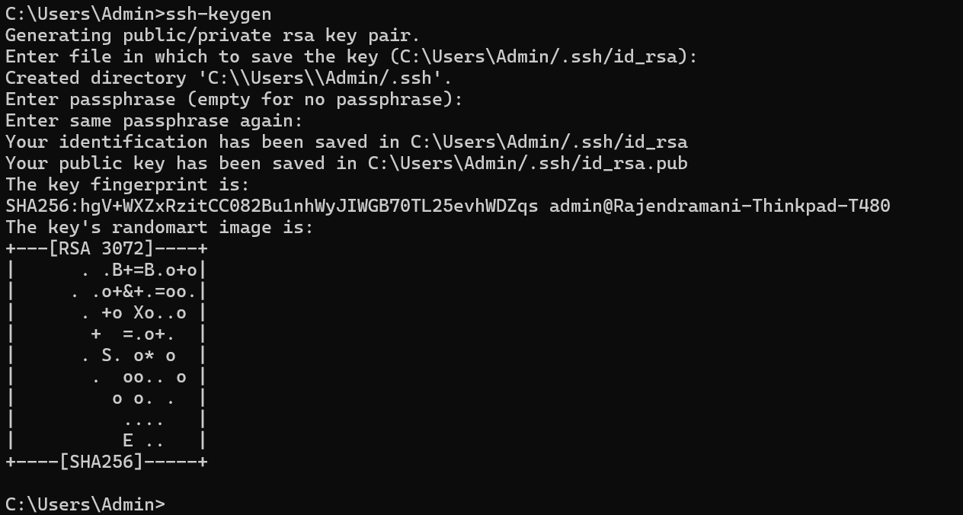

💾 Database
- SQL (MySQL/Postgres): schema design, normalization vs denormalization, indexes (B-tree/GIN), transactions & isolation levels, ACID, query plans, locking, partitioning.
- NoSQL: key-value vs document vs column; data modeling, consistency models, when to choose which.
- Caching: Redis (TTL, eviction, pub/sub), cache-aside/write-through.
- Backup/restore, migrations, connection pooling, read replicas, sharding basics.
- SQL Joins

Postgress
Install postgres via docker:

🎯 DSA
- Array/LinkedList/Stack/Queue, HashMap/Set, Tree/Trie/Heap, Graphs (BFS/DFS/Toposort), Sliding-window, Binary-search, Prefix sums, DP basics.
- Complexity (Big-O), recursion → iteration conversion.
- Practice: 100–150 problems (mixed easy/medium), patterns-ஆக குழுவாக்கி.

👆 Two Pointers
ஒரு Array அல்லது string-இன் மீது இரண்டு pointers ஐ வைத்து. logic-க்கு ஏற்றாற்போல நகர்த்துவது.
Two Pointers இல்லாமல் சில problems ஐ Brute Force முறையில் எப்படி அணுகுவது என்று பார்ப்போம் (Brute Force என்பது ஒரு problem ஐ தீர்க்க எல்லா முயற்சியையும் செய்து பார்ப்பது)
உதாரணமாக,
Problem 1: Given a sorted array, find if any two numbers add up to a target.
இதில் Brute Force (Nested Loops) ஐ பயன்படுத்தினால், ஒரு ஒரு element- உடன் மீதமுள்ள எல்லா elements ஐயும் check செய்வது
Problem 2: Remove Duplicates In-Place (Sorted Array)
இதிலும் Nested Loop-இல் ஒரு புதிய Array வை உருவாக்கி, ஒரு ஒரு element ஆகா சரி பார்த்து, அந்த array வில் சேர்ப்பது.
Problem 3: Reverse String / Array
புதிய Array வை உருவாக்கி, reverse copy செய்வது.

ஒரு array [1,2,4,7,11,15] வில் உள்ள இரண்டு numbers ஐ கூட்டினால் 15 வரவேண்டும் என எடுத்து கொண்டால் இதில் 21 comparisons இருக்கும். இதனுடைய Time Complexity O(n²) ஆகா இருக்கும்.
இதுவே Two Pointers ஐ apply செய்யும் போது 4 comparisons மட்டுமே இருக்கும். இதனுடைய Time Complexity O(n) ஆகா இருக்கும்.
அது எப்படி என்று பார்ப்போம்,
Inward Traversal:
அதாவது pointer A-வை 0th index இல் வைத்து, மற்றோரு pointer B ஐ last index இல் வைத்து நகர்த்துவது.
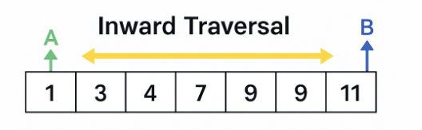

Unidirectional Traversal:
இதில் pointer A மற்றும் B ஐ ஒரே (0th) index இல் வைத்து, ஒன்றை மட்டும் move செய்வது
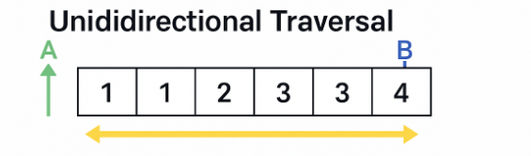
Staged Traversal:
இதுவும் Unidirectional Traversal போல தான், pointer B குறிப்பிட்ட element ஐ கண்டுபிடித்தவுடன், pointer A-வை வைத்து additional information ஐ collect செய்யலாம்.
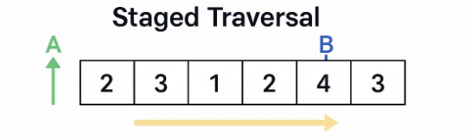

🌄 Spring
- Boot basics: starters, auto-config, profiles, configuration properties, validation.
- REST: controllers, DTO vs entity, exception handling, pagination, versioning.
- Data: JPA/Hibernate, Spring Data, entity relationships, lazy/eager pitfalls; migrations (Flyway/Liquibase).
- Spring Security: filters, authentication/authorization, method security.
- Observability hooks: Actuator, health checks, metrics.
- Microservice patterns: API-Gateway, Service Discovery, Config Server, Feign clients, Circuit breaker/Retry/Rate-limit (Resilience4j), Idempotency, Saga/Outbox.

🚪 Queue
- Concepts: topics/partitions, consumer groups, offsets, ordering.
- Delivery semantics: at-least-once/exactly-once; idempotent consumers.
- DLQ/Retry, backpressure; schema registry (Avro/Protobuf).
- Stream processing intro: Kafka Streams/Flink basics, windowing.

💹 Design Patterns
- Patterns: Repository, Factory, Strategy, Template, Adapter; in microservices—Saga, CQRS, Event sourcing (trade-offs).

💻 System Design
- Hard copy book: System Design Interview Volume 1 (Alex Xu)
- Soft copy pdf: System Design Interview volume 2 (Alex Xu)

📠 Dev Ops
Docker → CI/CD → Kubernetes → Terraform
- Docker: Dockerfile best practices, multi-stage builds, layers, Compose, image scanning.
- CI/CD: Git flow, build/test cache, artifacts, environment promotion (dev→staging→prod), blue/green & canary.
- Kubernetes: pods, deployments, services, ingress, HPA, configMap/secret, statefulsets, RBAC, Helm charts, readiness/liveness probes.
- Terraform: providers, resources, modules, variables/outputs, remote state & locking, workspaces, DRY structure.

⛈️ AWS
- IAM (users/roles/policies), KMS.
- Networking: VPC, subnets (public/private), route tables, IGW/NAT, SG vs NACL.
- Compute/Containers: EC2, ECS/EKS, Auto Scaling, ALB/NLB.
- Data: S3, RDS/Aurora, DynamoDB, ElastiCache, OpenSearch.
- Integration: SQS/SNS, EventBridge, API Gateway, Lambda.
- Observability: CloudWatch, X-Ray, CloudTrail; cost basics.
- Exam focus (DVA): deployment, security, development with SDKs, monitoring, troubleshooting.

🔐 Security
- AuthN/AuthZ, JWT, OAuth2/OIDC flows, scopes/claims, refresh tokens.
- Web security: CORS, CSRF, TLS, headers.
- App security: input validation, secrets management (vault/KMS).
- OWASP Top-10: SQLi, XSS, SSRF, etc. Threat modeling & rate limiting.

📈 Scalability & Performance
- NFRs: latency/throughput, availability (SLA/SLO/SLI), consistency, durability, cost.
- Core building blocks: load balancer, reverse proxy, API gateway, cache, CDN, DB (SQL/NoSQL), queue, object store.
- Scaling: vertical vs horizontal, replication (leader/follower), sharding, eventual consistency, read/write paths.
- Performance: profiling, GC tuning basics, connection pools, batching, pagination, N+1 fixes.
- Reliability: circuit breakers, timeouts, retries with jitter, bulkheads.

🧐 Monitoring & Observability
- Three pillars: logs, metrics, traces; structured logging & correlation IDs.
- OpenTelemetry basics; Prometheus scraping; Grafana dashboards.
- Tracing across services; SLOs/error budgets; alert design (signal/noise).
- Log pipelines: ELK/EFK; audit logging.

🪟 React Js
- Core: JSX, hooks (state/effect/memo/ref), context, custom hooks.
- Data-layer: fetch patterns, caching (React Query basic ideas), pagination, error boundaries.
- Routing, forms (React Hook Form), component composition.
- Performance: memoization, virtualization, code-splitting.
- Testing: React Testing Library.
- Build: Vite or CRA, env config.

